**Practice check**

1. Create a container registry

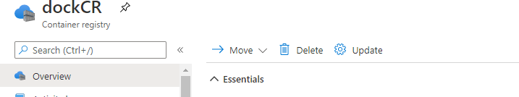

1. Create a kubernetes cluster with one node and add store along with secret key.

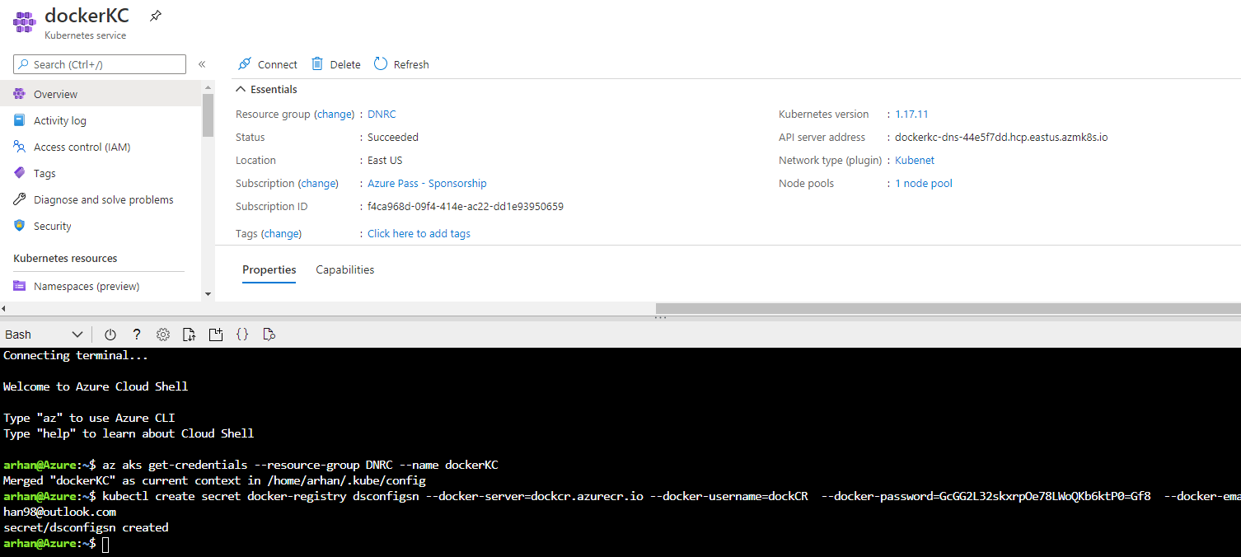

1. Use the devops starter for the default build and release.

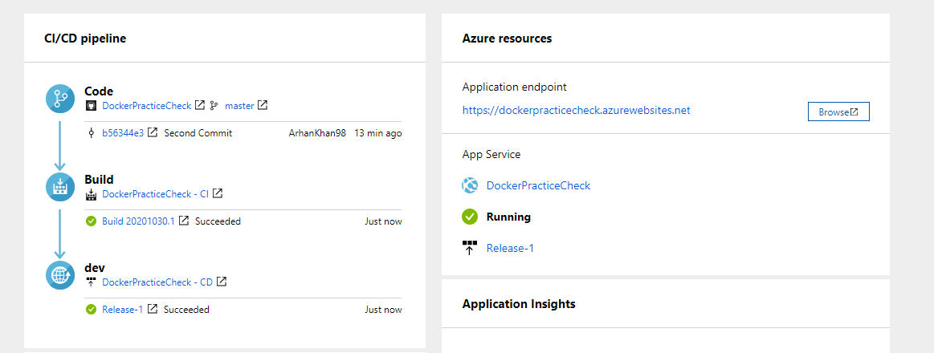

1. Make changes in the build pipeline
2. Change the machine to Ubuntu

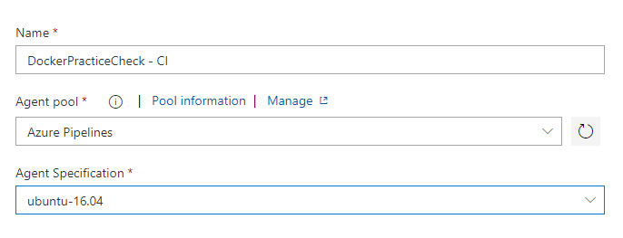

1. Uncheck the Zip published project.

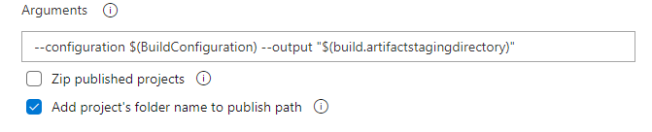

1. Add Container registry , add container repository and add “latest” in the tags

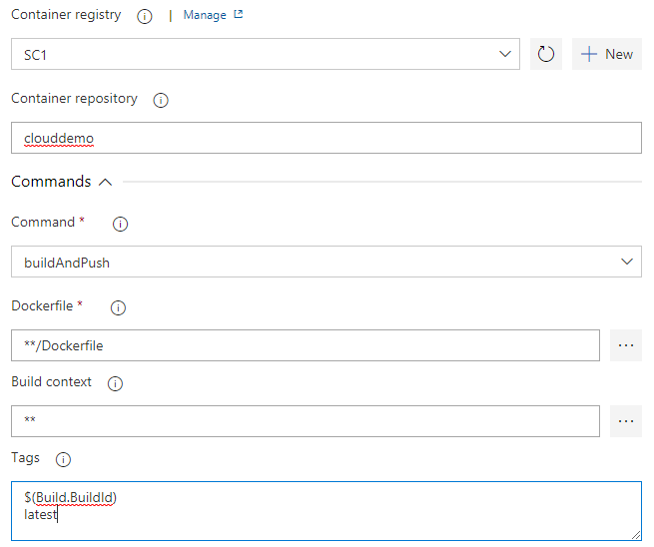

1. Make changes in the release pipeline by disabling the previous services and add docker.

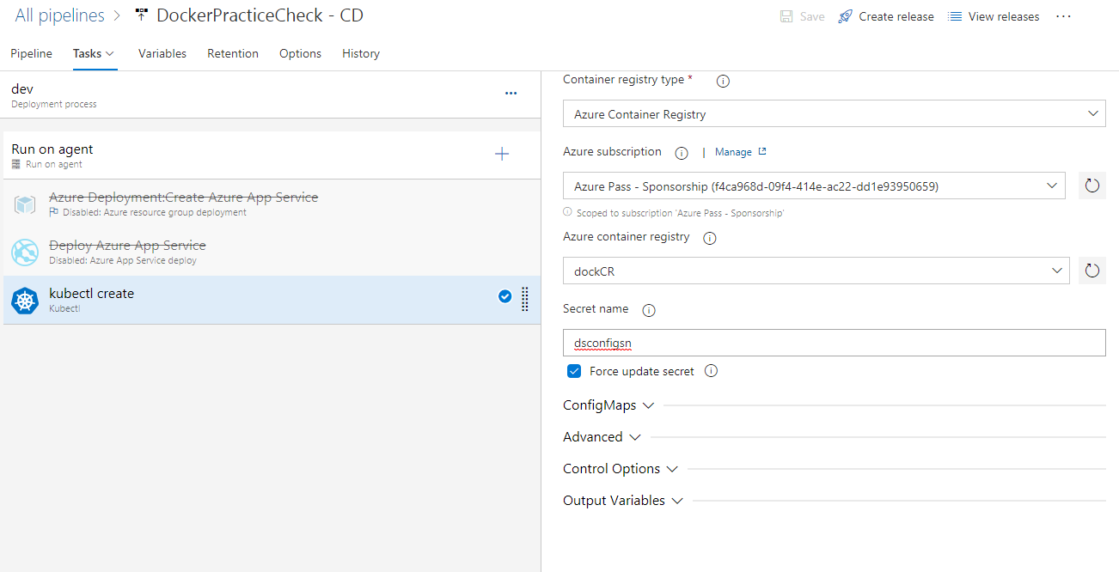

1. Create admin panel in kubernetes cluster shell and provide token to run.

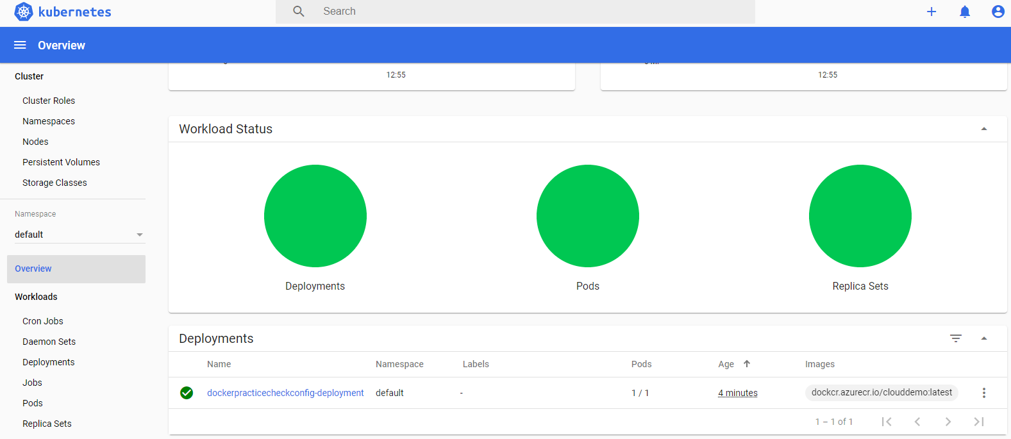

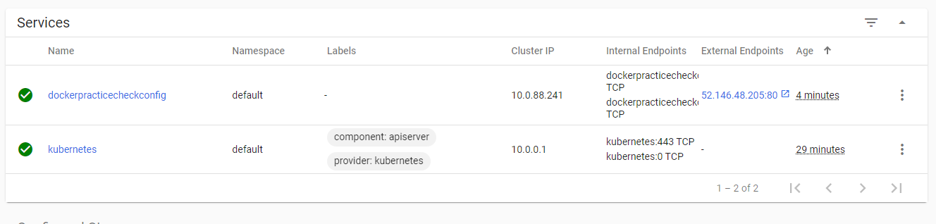

1. Open the url and add swagger to run the api using swagger.

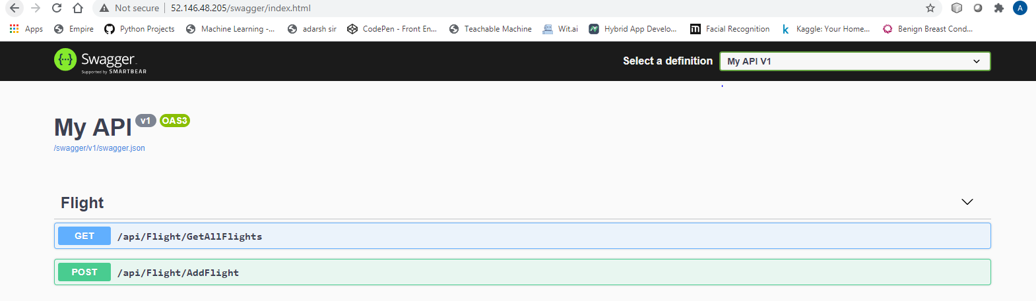

1. Displaying the content.

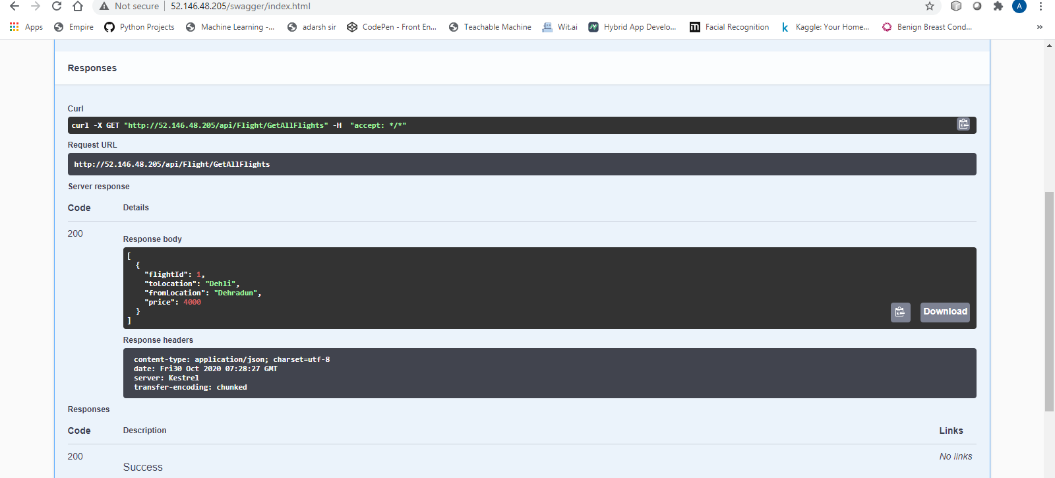

1. Adding a flight.

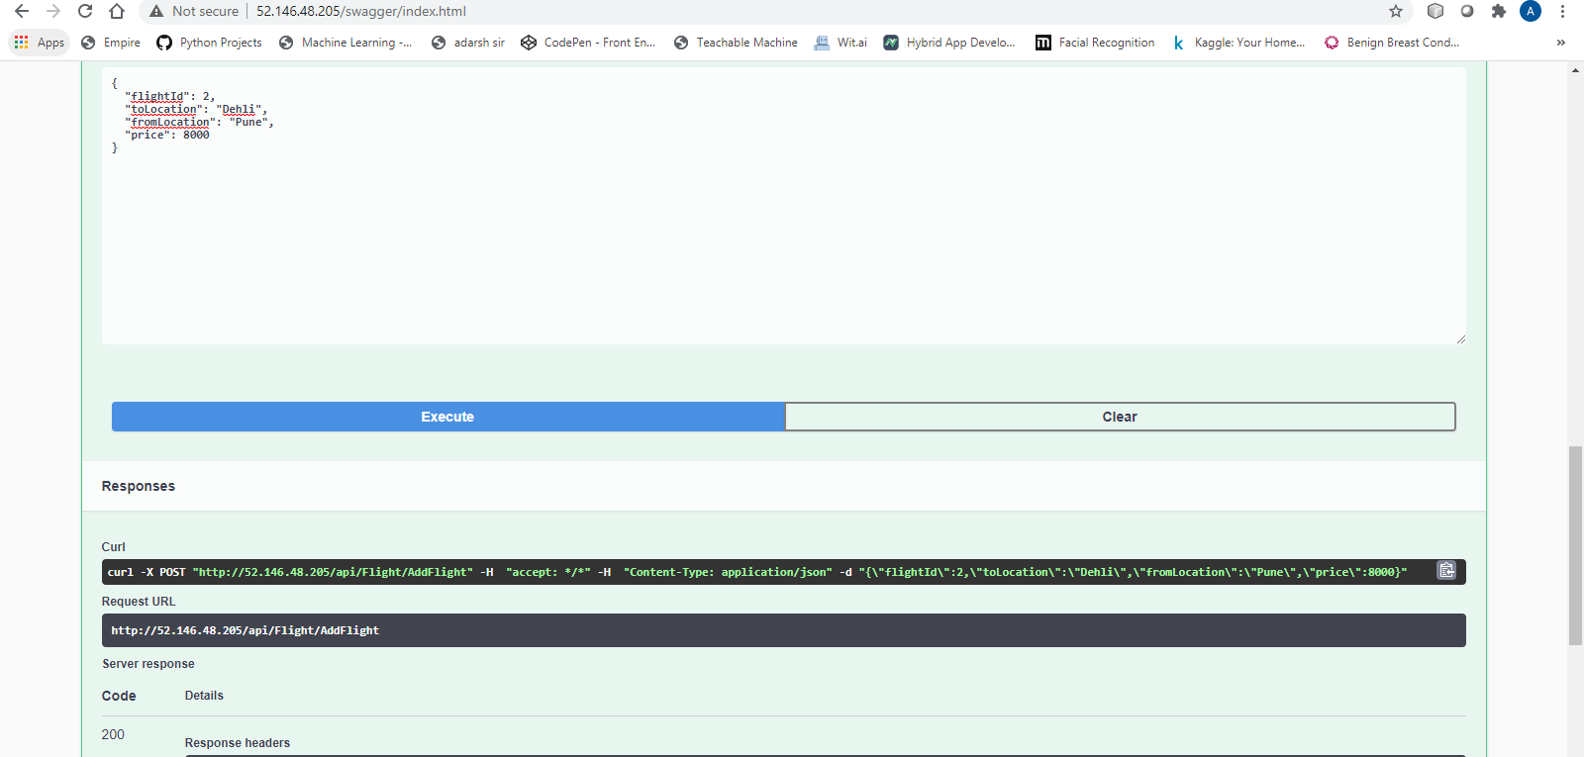

1. Displaying all the flights after the add operation.

